Installation Guide for

Virtual Machine for Computer Networks (CS F303) Lab

1. Download vdi file from the link: [https://drive.google.com/open?id=1x2XDsxr2cZsX77hghxGCI49t8FSG86X](https://drive.google.com/open?id=1x2XDsxr2cZsX7-7hghxGCI49t8FSG86X)
2. Install Virtualbox from the link : <https://www.virtualbox.org/wiki/Downloads>
3. Open the Virtualbox and click on New

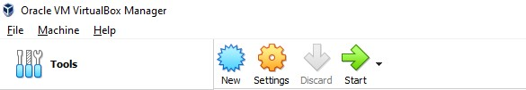

1. Give name to VM as NS2_VM
2. Select Type as Linux and Version as Ubuntu 64 and click on next

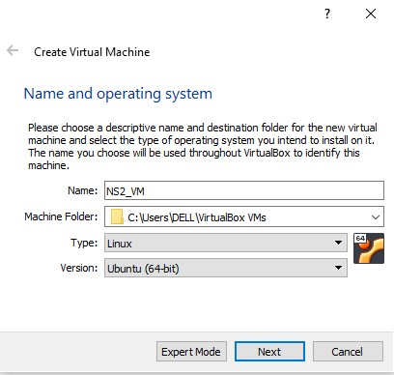

1. If you don’t see Ubuntu 64 as option then follow these steps :
   1. Reboot your system and go to Boot options
   2. Click on BIOS support / Advanced Settings
   3. Open Virtualization support
   4. Click on checkbox to enable Intel Virtualization technology.
   5. This will make Ubuntu 64 option available in your Virtualbox

1. Give memory size as 2048 MB and click on next

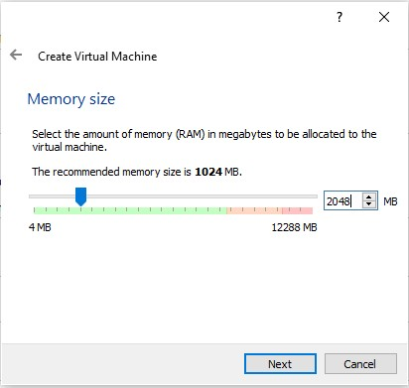

1. Select Use an existing virtual hard disk file

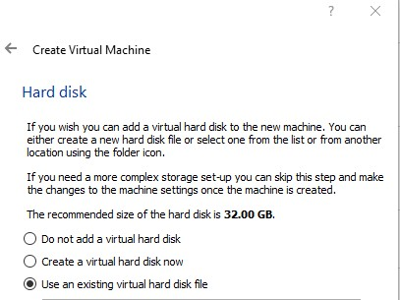

1. Click on folder icon on the right to choose vdi file from the disk.

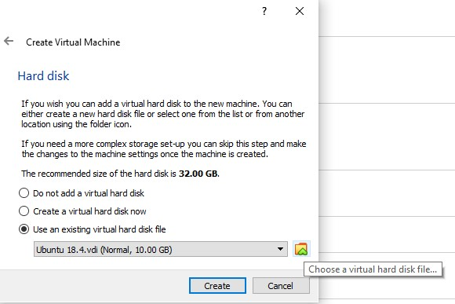

1. Click on Add and select downloaded vdi file. Click on Choose and Create.

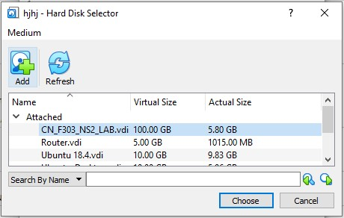

1. NS2_VM virtual machine will be created in the Virtualbox.
2. Now select NS2_VM and click on Start.